Experiment: 08
Aim
To perform form handling and event-based validation using JavaScript.
Software Required
- Visual Studio Code (or any code editor)
- Web browser (Google Chrome / Microsoft Edge / Mozilla Firefox)
- Live Server extension (or any local server) for VS Code
- Basic knowledge of HTML, CSS and JavaScript
Theory
Form handling in JavaScript refers to accessing, reading, and reacting to the data a user enters into HTML form elements such as text fields, number fields, radio buttons, checkboxes, and dropdowns. Each element can be accessed through the DOM using methods like document.getElementById(), and its current value can be read through properties such as .value (for inputs and selects) or .checked (for checkboxes and radio buttons). This allows a script to know exactly what the user has typed or selected at any given moment.
Event-based validation means checking the correctness of this data in response to specific user actions, rather than waiting until the form is submitted. JavaScript provides several events for this purpose: the input event fires every time a field's value changes (ideal for live, character-by-character validation), the change event fires when a dropdown or radio selection is updated, the blur event fires when a field loses focus (useful for a final check once the user moves on), and the submit event fires when the form is submitted, allowing a last validation pass before the data is accepted. Event listeners are attached using addEventListener(), and event.preventDefault() is used on the submit event to stop the default page-reload behaviour so the form can be handled entirely in JavaScript.
Validation itself is typically performed using conditional logic and regular expressions — for example, checking that an email matches a standard email pattern, that a phone number contains exactly ten digits, or that a required field is not left empty. Based on the result, the interface is updated dynamically: a field's CSS class is toggled to reflect a valid or invalid state, a hint message is shown only when something is wrong, and the submit button is enabled or disabled in real time depending on whether every field currently passes validation. This gives the user continuous feedback without needing to click submit to discover an error.
Once all fields pass validation and the form is submitted, the interface can be updated further to reflect the outcome — for instance, hiding the form and dynamically displaying a confirmation view populated with the data that was just submitted. This demonstrates the core idea of event-driven, DOM-driven interfaces: the page does not reload: JavaScript listens for events, validates data as it changes, and directly manipulates the DOM to keep the interface in sync with the current state of the form.
Case Study — Gym Admission Portal
Aim of the Case Study
To design and develop a gym admission portal using JavaScript that handles form input, performs real-time, event-based validation of user details, dynamically updates the interface, and displays an admission confirmation on successful submission.
Output
SnehaShah_24070521271

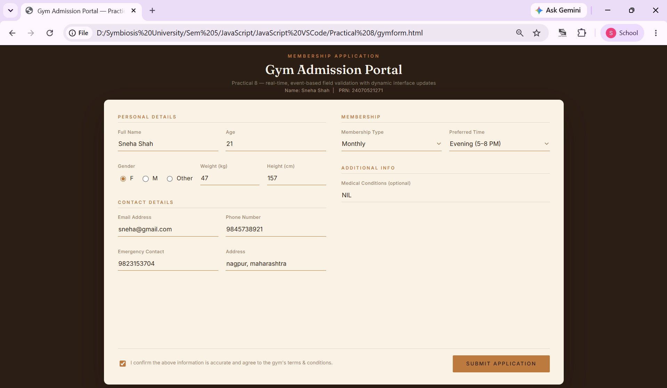
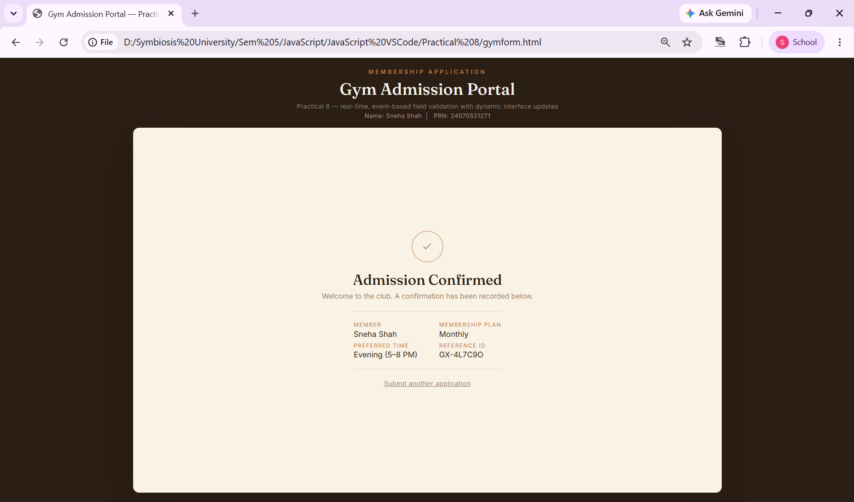
Result
The gym admission portal was successfully developed and tested. Each field in the form validates in real time as the user types or selects a value, using the input, change, and blur events — a field is only flagged when its value is invalid, while a correctly filled field is accepted silently. The Submit button stays disabled until every required field passes validation and the terms checkbox is accepted, ensuring incomplete or incorrect data cannot be submitted. On successful submission, the form is dynamically replaced within the same interface by a confirmation view that displays the applicant's name, selected membership plan, preferred time slot, and a generated reference ID, confirming that the admission was recorded.
Conclusion
Thus, the concepts of form handling and event-based validation in JavaScript were studied and successfully implemented through a gym admission portal. The application demonstrates how DOM access, event listeners, and conditional validation logic work together to give users immediate feedback, and how the interface can be dynamically updated — without a page reload — to reflect both validation state and a final confirmation once the form is submitted correctly.

